الجمهورية اللبنانية
وزارة التربية والتعليم العالي الامتحانات الرسمية لشهادة الامتياز الفني
المديرية العامة للتعليم المهني والتقني لدورة عام 2011 الاولى
===============
الاختصاص والرمز : المعلوماتية الادارية (24004) –الانظمة والشبكات (24101)
المادة : التطوير التطبيقي بالانترنت – البرمجة بلغة الانترنت المعدل: (8-6)
المستندات المسموح بها : لا شيء المدة : ساعة ونصف

Treat the following questions: (5pts/question)
N.B: All the "HTML" files are in the folder: \main
All the "AUDIO" and "VIDEO" files are in the folder: \main\sounds
All the "IMAGES" files are in the folder: \main\photo
All others files are in the folder: \main\misc

I- Write the appropriate tags to obtain as a result the following page " Main1.html" respecting the following conditions:  - The page author is « webmaster ».  - The keywords used by search engines are: "Gift, Shop, and Valentine".  - The title has the biggest possible size, the color is red and the font is "Times New Roman".  - The Video « Valentine.wmv » is infinitely played when the mouse cursor is above the video window.  - The message« Cupid always plays a role in the timeless celebration » is a scrolling message from right to left repeated 10 times.  - The color of « Copyright 2011 » is green.  - The link « Contact US » send an e-mail to ‘contact@valgift.com’ .  - The numbers and bullets are lists. | 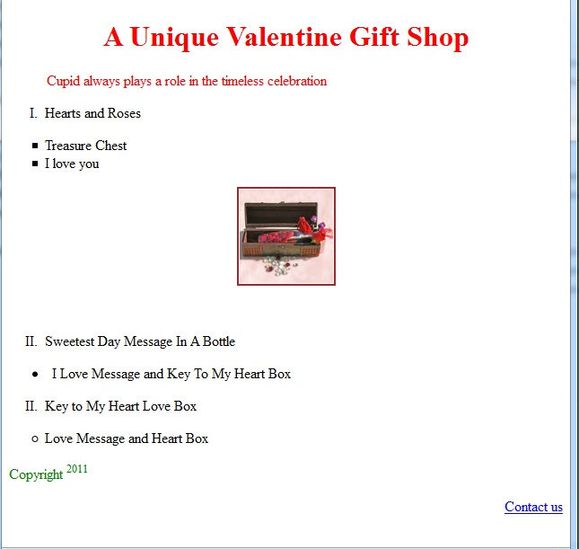
II- Write the appropriate tags to obtain as a result the following page " Main2.html" respecting the following conditions:  - The page title is « catalogue »  - The visited links have a Red color.  - The name of the images are respectively img2.jpg, img3.jpg and img4.jpg.  - The background color of the table is blue.  - The table borders have 2 colors: green and red. The thickness is 4 pixels.  - The distance between the cells is 2 pixels.  - The link « Download Catalogue » download the file « catalogue.zip »  - The links « other shops » open the page « google.com » | 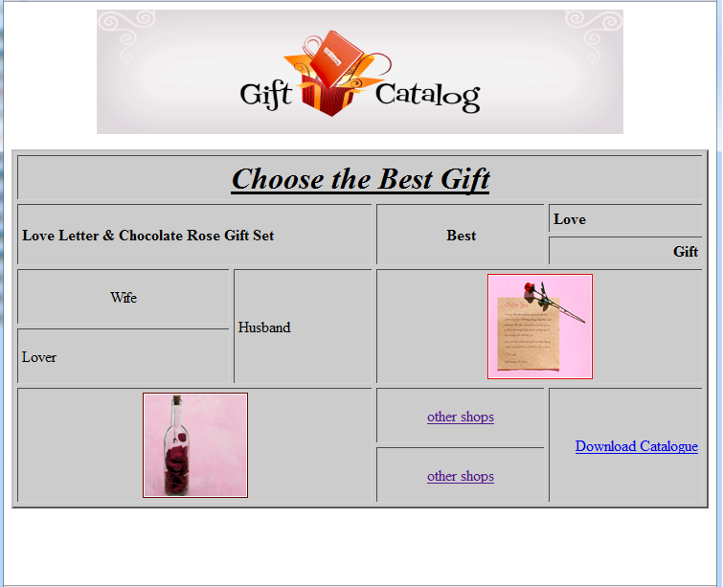

الاختصاص والرمز : المعلوماتية الادارية (24004) –الانظمة والشبكات (24101)
المادة : التطوير التطبيقي بالانترنت – البرمجة بلغة الانترنت المعدل: (8-6)
المستندات المسموح بها : لا شيء المدة : ساعة ونصف

 | III- Write the appropriate tags to obtain as a result the following page " Main3.html" respecting the following conditions:  - The link «Bottom» scroll the page down and the link « Top » scroll the page up.  - First Name: Entry Field of 50 characters maximum where only 20 are displayed.  - Last Name: Entry Field of 50 characters maximum where only 20 are displayed.  - Address: Entry field of 60 characters and 4 lines.  - « Female » and « Male » only one of these two values can be chosen.  - « Occasion » contains the following values: ‘Valentine’, ‘Birthday’ and ‘Special Occasion’.  - « Preferred Color » contains three values: ‘Red’, ‘Pink’, and ‘White’. We can choose multiple values. The default chosen value is ‘Pink’.  - The button Submit send the data to the e-mail « News@valgift.com ».  - The button Reset restores the default values. | 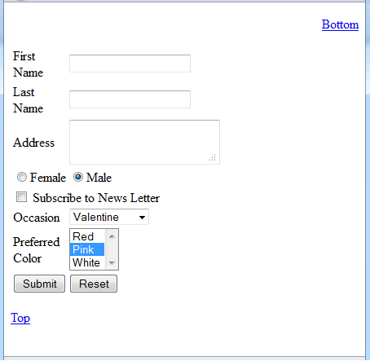

IV- Write the appropriate tags to obtain as a result the following page " index.html" respecting the following conditions  - This page is divided into three frames A, B and C.  - The first frame "A" contains only the sentence « Coming Soon ».  - The second frame B contains the links « Main Page », « Catalogue» and «Guest Book». These links respectively display the page « Main1.html » in the frame C, the page « Main2.html » in frame C and the page « Main3.html » in a new page. The 4 lines in this frame have: a thickness of 4 pixels and a red color.  - The third frame C displays by default the page « Main1.html ».  - Create all inexistent needed pages and add the needed tags to preceding pages. | Frame A:  Height: 80 %  Width:20%  Frame B:  Height : 20 %  Width: 100%  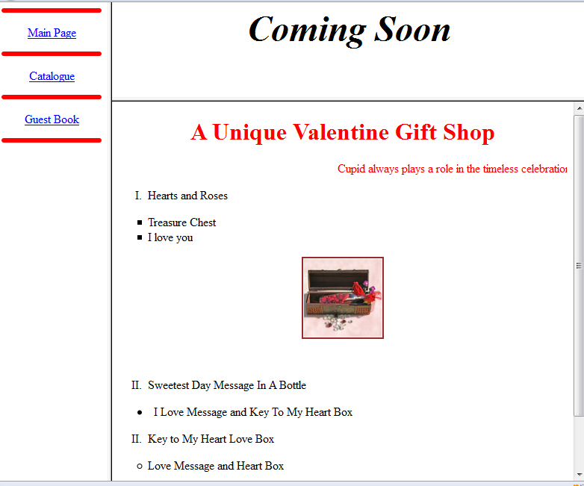  Cadre C:  largeur 85 %  hauteur:70%  Frame C:  Height: 80%  Width:80 %

